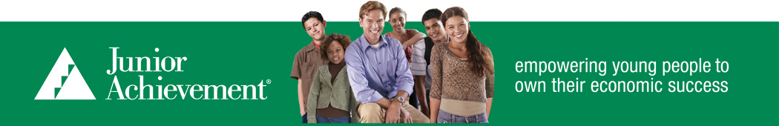

Buzz Knoles Junior Achievement Scholarship Application (2023)
Name: _____________________________________________________
Address: ___________________________________________________
City: ______________________ State: ___________ Zip: _________
Telephone: ______________________
High School: ________________________________________________
Grade: _____________ Birth Date: ____________________________
Scholarships must be used in an educational endeavor. An award may be used for studies at any college, university, vocational or trade school. Every student who applies must complete the application and provide an official high school transcript and recommendation from a teacher. If the Junior Achievement class was taken during the elementary grades or middle grades, any High School teacher may provide the recommendation. A teacher recommendation form comes with the application.
All applicants for a Junior Achievement Scholarship will be evaluated based upon the following criteria: Academic Transcript (GPA); Community Involvement and Activities; Junior Achievement Participation; Demonstrated Leadership; and Recommendations.
All funds will be paid directly to the student’s school of choice during their first year of attendance.
Mail applications and letters of recommendation to:
Ross County Junior Achievement
P.O. Box 359
Chillicothe, Ohio 45601

For questions, please call or text Ty Park at 740-253-1245.

Applications must be returned by March 10, 2023
Scholarship Checklist

Before you remit this application, consider double checking to ensure that all required items are included. See the checklist below.

Educational Information
Academic Transcript
Teacher Recommendation(s)

If you participated in a Junior Achievement Class fill out and return the appropriate page:
JA Company Program (high school)
Any other JA Class – from 4th grade through high school

If you did NOT participate in a JA Class, fill out and return the Business- or Job-Related Work Experience page:
Business- or Job-Related Work Experience

Buzz Knoles Junior Achievement Scholarship Application
All Applicants
(2023)

Educational Information:

Expected date of High School Graduation: _________________________

G.P.A which includes Advanced Placement adjusted to 4.0 scale: ______________
High School Activities/Extra Curriculars / Any Positions Held?

List any community or volunteer activities:

Explain your educational goals:

Have you received a “full tuition” scholarship to the school of your choice? __________

Have you received a “full tuition plus room and board” scholarship to the school of your choice? __________

Schools to which you have applied:
___________________________________________________________________________________________________________________________________________________________________________________________________________________________________________________________________________________

JA Company Program Experience
Complete this page if you participated in the Junior Achievement Company Program at your high school.

What product did your company sell? _________________________________

What were your class duties in the class?

What was your greatest personal accomplishment?

What was your greatest challenge in the class?

What was the most important concept you learned in J.A. Economics?

Another JA Program Experience
Complete this page if you participated in a Junior Achievement class other than the Company Program

Grade(s) of participation (check all that apply):
Elementary (4th or 5th grades) Our Region
Middle School (6th, 7th, or 8th grades) Economics For Success
High School (9th – 12th grades) Career Success/Be Entrepreneurial

Explain the concepts you learned or were reinforced from your participation in the J.A. class:

Explain how these concepts will help you in the future:

Business- or Job-Related Experience
Complete this page if you did not participate in a Junior Achievement Class

Business- or job-related experience:_____________________________________

Date of participation: _______________________________________________
What was your position? ____________________________________________
What were your duties? _______________________________________

What concepts did you learn from this experience?

How will these concepts help you in the future?

What was your greatest challenge in your job?

What was the most important concept you learned from the job?

Recommendation for Junior Achievement
(Confidential)

Student Name: _________________________________________________

School: _______________________________________________________________

Your Name: __________________________________________________________

Relationship to Student: Teacher or Employer

What were the student’s responsibilities in your class or job site?

Were the responsibilities completed as expected?

What are the student’s strengths?

In what areas does the student need to grow?

Would you recommend this student for a job? Why?

How would you rank this student among his/her peers?

Top 10% Top 20% Top 50% Lower 50%

On a scale of 1(lowest/poor) to 10(highest/best) please rate the student in:

Leadership _____

Effort _____

Quality of Work _____

Attitude _____

Teamwork _____

Please list any other comments you feel will help the selection committee to understand why this student is or is not deserving of a scholarship:

_____________________________________
(Signature)

